# Graduate Assignment C

Han ZHANG

u7235649

I have read the ANU Academic Skills statement regarding collusion. I have not engaged in collusion in relation to this assignment.



27/05/2021 1pm

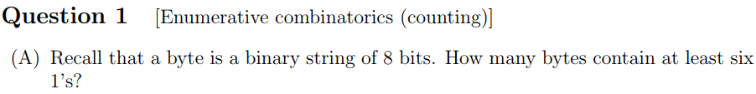



















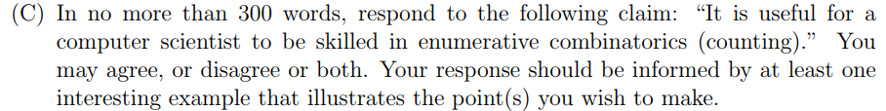

I think it is useful. Enumeration combinatoric problems are very common in computer science, such as password cracking, writing test cases, and so on. For example, when writing test cases for white box testing, different input parameters may correspond to different outputs, and we need to test the code completely in all cases by finding all possible combinations of input parameters. Also, when testing a system, a process may consist of multiple small processes, the order of the small processes may affect the output results. When testing, all possible permutations should be found through permutation and combination and verify whether the result can meet the requirements.

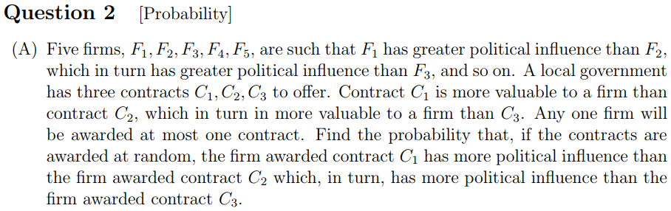



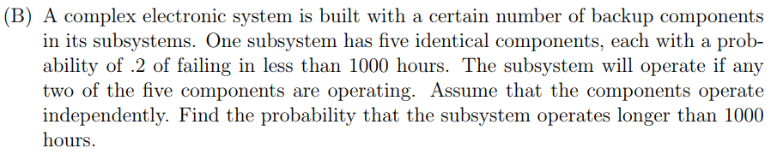



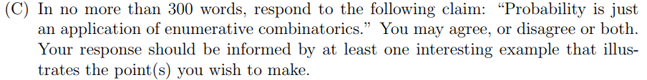

I partly agree with this claim, but probability is not just an application of enumerative combinatorics. Discrete probability models can usually be solved with enumerative combinatorics, for example the probability of throwing a dice a few times to get a certain point. But for the continuous probability model, because there are infinite possibilities, it is impossible to calculate the probability through enumerative combinatorics, for example, the probability of a train arriving at a station in a certain period of time.

  










